SMART

new frontier group

React application

Practice task:

First, let’s decide the nature of the app we want to build. In this guide, we’d prefer not to spend too much time on the back-end, so we’ll write something based on data that’s easily attainable on the Internet—like a sports feed app.

We will use an autosport API service to act as our back-end. Luckily, the guys at Ergast are kind enough to provide a free motorsport API that will be perfect for us.

Application will have three main views:

* As we’re trying to build a sports feed for a racing championship, let’s begin with the most relevant view: the championship table.
* From the championship table, when you click on any driver name, goes to list of driver's results on all grand prix's.
* From the list of driver's results, when you click on a specific grand prix, goes to standings for this specific grand prix.

You will use ReactJS.

You will organize the static part with HTML and CSS.

An example screenshots are shown below.

Click on Drivers menu link need to show Drivers Championship page (this is also default page)

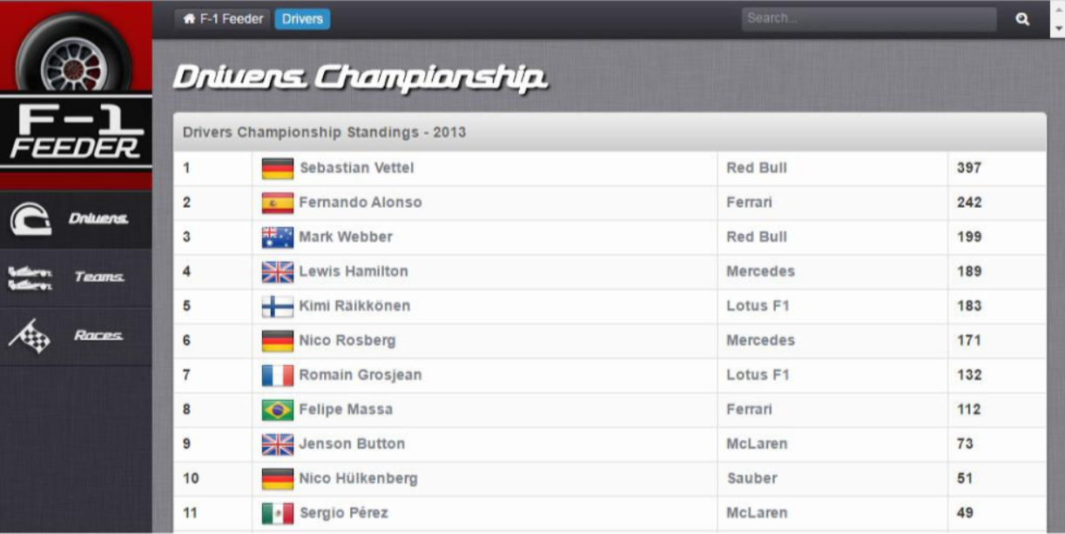

If you click on driver name for example Sebastian Vettel you need to show all details about this driver for actual session as you can see on page below:

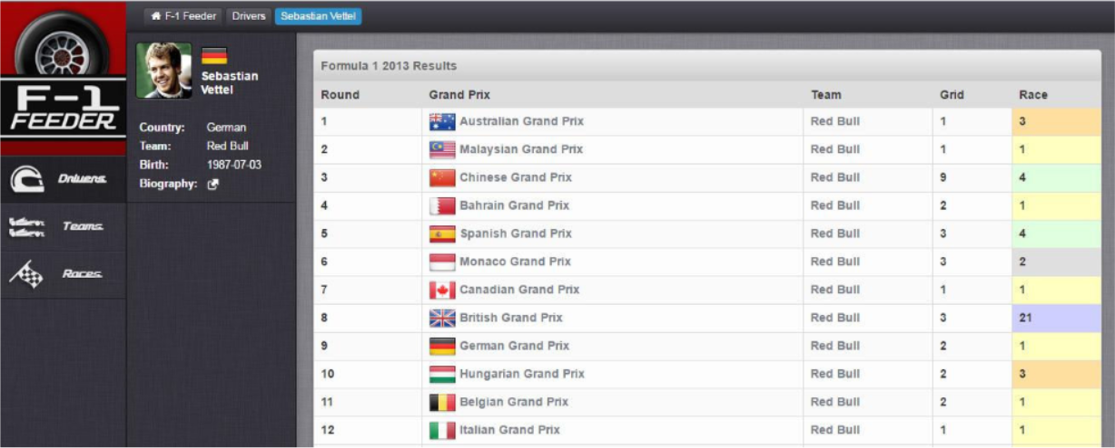

Click on Teams menu link need to show all about constructors as on page below:

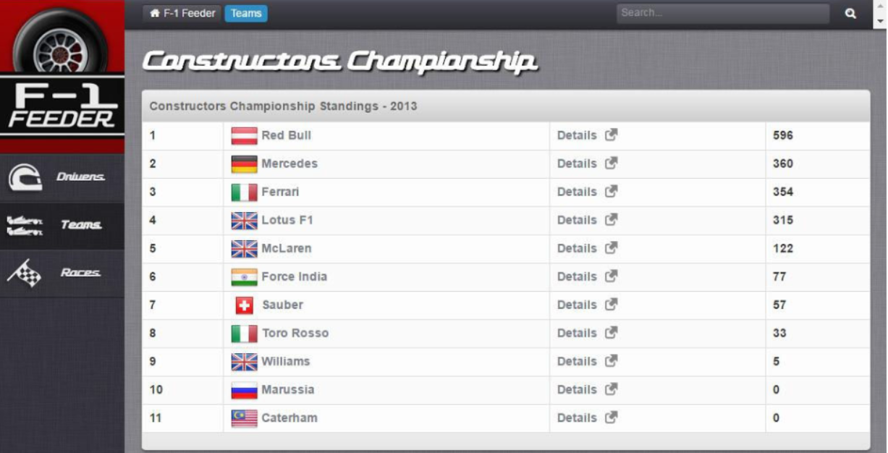

If you click Team link for example if you click RedBull links on picture above you need to show all races on which this team was competitioning as you see on picture below:

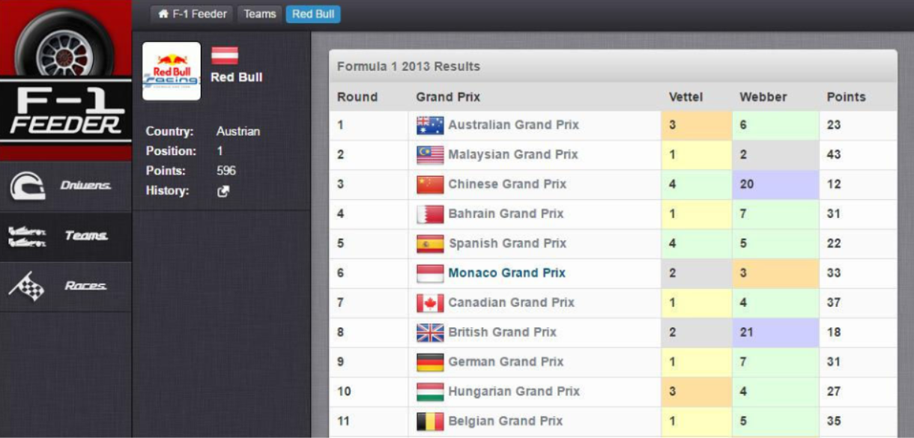

If you click on details links in Teams menu for example details link for RedBull it need to link you to wikipedia information about this racing team:

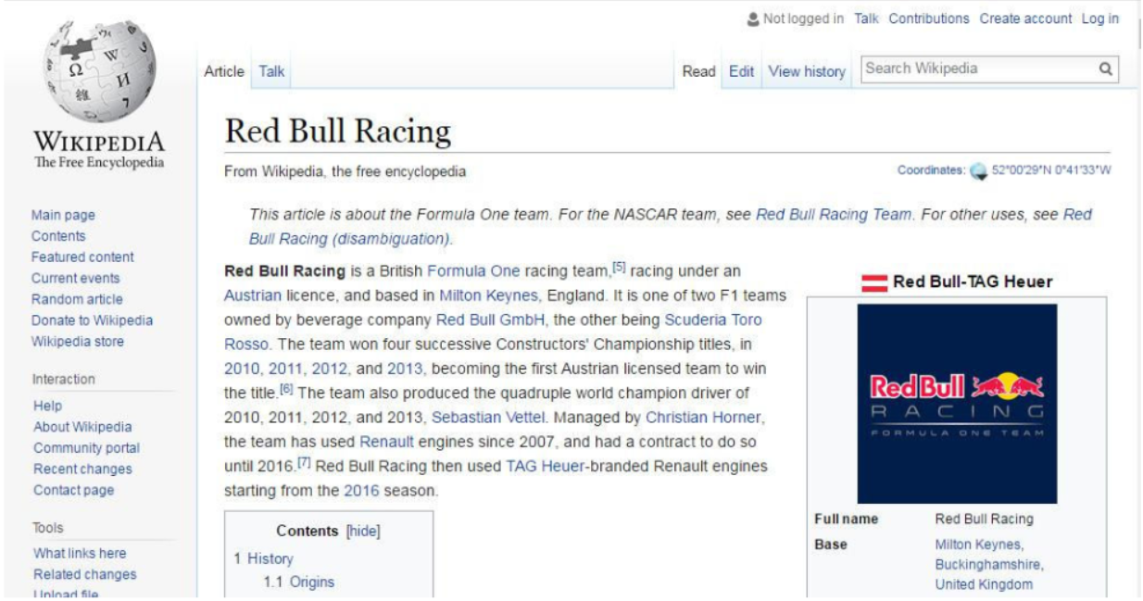

If you click grand prix link for example Australian Grand Prix it will link to race and qualifying results as you can see on picture below:

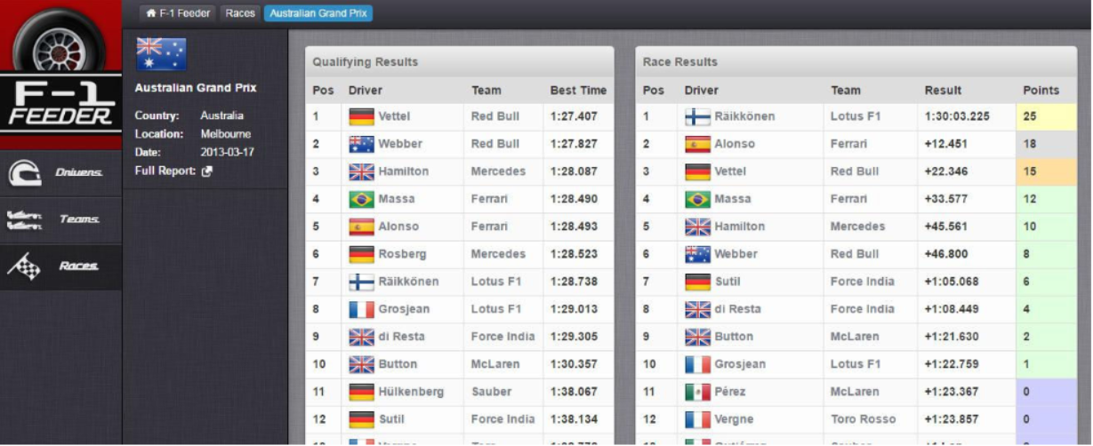

Click on Races menu link need to show Race Calendar for actual year:

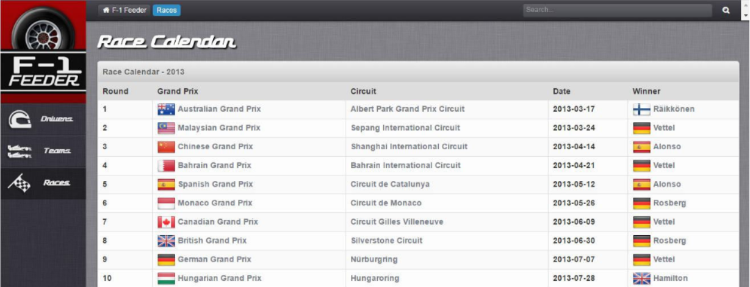

All other links lead to same links mention above.

All API for this task can be found on:

<http://ergast.com/mrd/>

Here are detailed API for this project :

**AllDrivers**: 'http://ergast.com/api/f1/' + year + '/driverStandings.json'

**DriverDetails**: 'http://ergast.com/api/f1/' + year + '/drivers/' + id + '/driverStandings.json'

**DriverRaces**: 'http://ergast.com/api/f1/' + year + '/drivers/' + id + '/results.json'

**AllTeams**: 'http://ergast.com/api/f1/' + year + '/constructorStandings.json'

**TeamDetails**: 'http://ergast.com/api/f1/' + year + '/constructors/' + id + '/constructorStandings.json'

**TeamResults**: 'http://ergast.com/api/f1/' + year + '/constructors/' + id + '/results.json'

**AllRaces**: 'http://ergast.com/api/f1/' + year + '/results/1.json'

**Qualifiers**: 'http://ergast.com/api/f1/' + year + '/' + id + '/qualifying.json'

**Results**: 'http://ergast.com/api/f1/' + year + '/' + id + '/results.json'

For additional task implement different colors for displayed positon place after race.

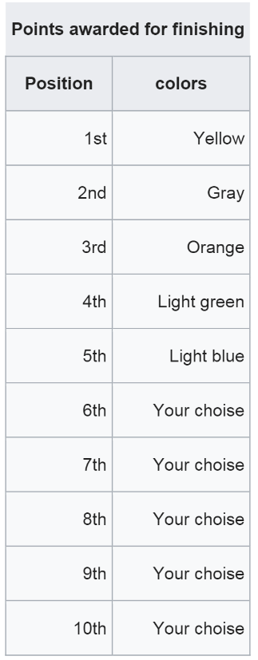

All other position make dark grey.

Prerequisites: This course is for intermediate web developers with some experience with JavaScript, and some prior experience with a JavaScript library, such as ReactJS.

Students should also be proficient in HTML and CSS, and should have experience creating static pages.

Estimated duration: 2 weeks